Andy Greenhalgh

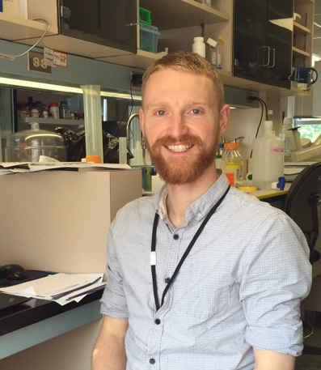photo récente

Statut : Agreenskills+ ResearchFellow
CV :
- (25-01-1985)
- Diplômes : PhD Neuroscience, University of Manchester, UK
- PARCOURS : 5 lignes max
CONTACTS :
Nom : Andy Greenhalgh
Tel : +33 634573933
e-mail : andrew.greenhalgh@inra.fr
RATTACHEMENT : NeutriNeuroLab
THEME DE RECHERCHE : My fundamental research interest is the immune system’s role in central nervous system(CNS) injury and disease. More specifically, the role of inflammation after a physically traumatic event, such as head or spinal cord injury. During my postdoctoral work at McGill University, I begun to investigate important cells involved in the immune response to a spinal cord injury; microglia and macrophages. These are key cells involved in the recovery of CNS tissue. Microglia are the brain and spinal cord’s resident immune cell, whereas macrophages infiltrate the CNS from the blood, after injury. We are now beginning to understand the interconnected role of these cells and that lipid content and signalling could be crucial in their function.
COMPETENCES :

Multiple in vivo, ex vivo, in vitro and molecular biology techiques such as:
CNS injury models of stroke, haemorrhage and spinal contusion.
Behavioural monitoring in multiple motor and cognitive tasks (mouse/rat)
Various immunohistochemical, immunofluorescence and histological techniques
Microglial cell isolation from healthy/diseased CNS tissue
Immune cell phenotyping and sorting with fluorescently activated cell sorting (FACS)
Cell culture of primary adult mouse microglia and other myeloid cells
Transcriptional-profiling of microglia using Affymetrix microarray platforms

PUBLICATIONS :

Anderson WA†, Greenhalgh AD†, Takwale A, David S, Vadigepalli R (2017). Novel influences of IL-10 on CNS inflammation revealed by integrated analyses of cytokine networks and microglial morphology. Front Cell Neurosci.Aug 14;11:233.†authors contributed equally.
Greenhalgh AD, Passos dos Santos R, Zarruk JG, Salmon CK, Kroner A, David S (2016). Arginase-1 is Expressed Exclusively by Infiltrating Myeloid Cells in CNS Injury and Disease. Brain Behav Immun; 56: 61-7.
Kroner A, Greenhalgh AD, Zarruk JG, Passos Dos Santos R, Gaestel M, David S (2014). TNF and increased intracellular iron alter macrophage polarization to a detrimental M1 phenotype in the injured spinal cord. Neuron. Sep 3; 83(5):1098-116.
Greenhalgh AD, David S (2014). Differences in the phagocytic response of microglia and peripheral macrophages after spinal cord injury and its effects on cell death. J Neurosci. Apr30;34(18):6316-22
Greenhalgh AD, Brough D, Robinson EM, Girard S, Rothwell NJ, Allan SM (2012) Interleukin-1 receptor antagonist is beneficial in rat subarachnoid haemorrhage by blocking haem driven inflammation. Dis Mod & Mech 6:823-33

